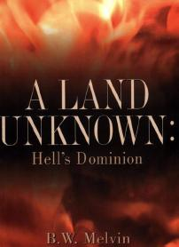
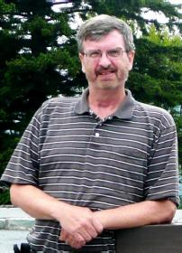
After Hours Ministry
2627 Paddington Road
Fort Collins, CO 80525
Phone: 970-206-4620


Thank you for inviting B. W. Melvin to your church/organization to share his dynamic Christ centered testimony. Please fill out this preliminary contact information and return by mail so we can better prepare for upcoming services and/or gatherings.

Ministry Contact Information:

Church/Organization Name: ___________________________________________
Address: __________________________________________________________
City, State, Zip: _____________________________________________________
Church/Organization Phone: __________________________________________

Host/Contact Person: ________________________________________________
Office Phone: ______________ _ Cell /Mobile: ____________
Email: ____________________________________________________________
Pastor Name: ______________________________________________________
Office Phone: ______________ Cell /Mobile: _________
Email: ____________________________________________________________

Meeting/Event Description: __________________________________________
Approximate Group Size: ____________________________________________
Venue Type/Configuration: __________________________________________
Date(s) Requested: ________________________________________________

All information provided on this form is confidential and will only be used for ministry purposes.

